
American International University-Bangladesh (AIUB)

Faculty of Science & Technology (FST)
Department of Computer Science

Natural Language Processing
Mid-Term Project Report
Summer 2025-2026

Section: B
Group: 02

Project Contributions

SL  # | Student Name & ID | Contributions (mention every part of the project where you contributed)
1. | Name: NILOY PAUL  ID: 23-51773-2
2. | Name: ARNOB SARKER SUPTA  ID: 23-52080-2
3. | Name: NAZMUS SAKIB  ID: 23-52638-2
4. | Name: AFNAN UR RAYAN  ID: 23-51992-2

Dataset Description

Dataset 1: DAIGT V2 Train Dataset (Kaggle)
Total rows: 44,868 essay samples (commonly cited as 44,800–44,868 depending on the exact CSV version)
Classes: 2 (binary classification) label column: 0 = human-written, 1 = AI-generated
Class balance: 27,371 human-written vs 17,497 AI-generated (roughly 61% human / 39% AI imbalanced, mimicking real-world proportions)
Key columns:
- text — the essay content
- label — 0/1 binary target
- prompt_name — which essay topic/prompt it responds to (e.g., "Car-free cities," "Driverless cars," "Exploring Venus")
- source — origin of the text (e.g., persuade_corpus, chat_gpt_moth, llama2_chat, falcon_180b, darragh_claude, radek_500, kingki19_palm)
- RDizzl3_seven — flag marking whether the row belongs to the 7 prompts known to overlap with the competition's hidden test set
AI sources represented: ChatGPT (GPT-3.5), GPT-4, LLaMA-2-70B, Falcon-180B, PaLM (Google), and 2,000 Claude-generated essays
Human data: primarily from the PERSUADE 2.0 corpus (student-written argumentative/expository essays)
Text type: short-to-medium academic/persuasive essays, single-topic
License: MIT for newly contributed data; underlying sources retain their original licenses

Dataset 2: HC3 (Human ChatGPT Comparison Corpus)
Purpose: First large-scale corpus directly comparing human vs. ChatGPT answers the same questions, for detection research (paper: How Close is ChatGPT to Human Experts? arXiv 2301.07597).
Total rows: 24,322 (per HF dataset viewer) often cited as 24.3k question-answer pairs in the "all" config since each row holds both a human and a ChatGPT answer as parallel sequences
Classes: 2 (binary) humans vs. ChatGPT, though it's structured as paired Q&A rather than pre-labeled rows; you generate labels by splitting human_answers vs chatgpt_answers
Languages: English and Chinese
Subsets (by domain), all within "all" config:
- reddit_eli5: 17.1k rows (largest subset, from Reddit's "Explain Like I'm Five")
- finance: 3.93k rows
- medicine: 1.25k rows
- open_qa: 1.19k rows
- wiki_csai: 842 rows (Wikipedia + computer science/AI questions)
- (a Chinese-language medical subset also exists in the broader HC3 release)
Key columns:
- id
- question — the prompt/question
- human_answers — list of one or more human responses
- chatgpt_answers — list of one or more ChatGPT responses
- source — which subdomain (eli5, finance, medicine, etc.)
Class balance: about 69% human vs. 31% ChatGPT (58,546 human answers vs 26,903 ChatGPT answers) (since each question typically has both answers)
Text type: long-form Q&A responses across varied domains (contrasts with DAIGT's essay format)
License: CC-BY-SA-4.0 (or stricter, inheriting from source datasets)

Project Implementation Detail
- Import libraries and download NLTK resources
Description:
Everything the project needs is loaded in one place. Along with the libraries, the cell pulls down the NLTK data files used later by the tokenizer, the stop-word list and the lemmatizer. The print at the end is there so the cell reports something instead of finishing silently.
Code:
import re
import pandas as pd
import numpy as np
import nltk
from nltk.corpus import stopwords
from nltk.stem import WordNetLemmatizer
from nltk.tokenize import word_tokenize
from sklearn.model_selection import train_test_split
from sklearn.feature_extraction.text import CountVectorizer, TfidfVectorizer
from sklearn.naive_bayes import MultinomialNB
from sklearn.linear_model import LogisticRegression
from sklearn.svm import LinearSVC
from sklearn.metrics import accuracy_score, precision_score, recall_score, f1_score, classification_report, confusion_matrix, ConfusionMatrixDisplay
import matplotlib.pyplot as plt
nltk.download('punkt')
nltk.download('punkt_tab')
nltk.download('stopwords')
nltk.download('wordnet')
nltk.download('omw-1.4')
Sample output:
[nltk_data] Downloading package punkt to /root/nltk_data...
[nltk_data] Unzipping tokenizers/punkt.zip.
[nltk_data] Downloading package punkt_tab to /root/nltk_data...
[nltk_data] Unzipping tokenizers/punkt_tab.zip.
[nltk_data] Downloading package stopwords to /root/nltk_data...
[nltk_data] Unzipping corpora/stopwords.zip.
[nltk_data] Downloading package wordnet to /root/nltk_data...
[nltk_data] Downloading package omw-1.4 to /root/nltk_data...
True

Code description:
pandas and numpy handle the tables, re supplies the cleaning regular expression, nltk provides the tokenizer, stop-word list and lemmatizer, and sklearn brings the two vectorizers, the three classifiers and the metrics. matplotlib is only needed for the confusion matrices later. The nltk.download calls fetch small resource files the first time and reuse the cached copies afterwards.
- Extract Dataset from Google Drive Links
Description:
The two dataset files sit in Google Drive rather than on the machine running the notebook, so this cell holds the direct download links that pandas read from. SAMPLE_PER_CLASS is set here as well, since the balancing step further down depends on it.
Code:
SAMPLE_PER_CLASS = 3000
path_daigt_download = 'https://drive.google.com/uc?export=download&id=1L1a5lPNUSjmLA167XT3Yv-S55d9FaW0U'
path_hc3_download = 'https://drive.google.com/uc?export=download&id=1Dse8l3ct3elof5gqvVWcl0_Wfm38RsV0'
print('Google Drive download links for DAIGT V2 and HC3 datasets are configured.')

Sample output:
Google Drive download links for DAIGT V2 and HC3 datasets are configured.

Code description:
SAMPLE_PER_CLASS is the balanced sample size used later. The two path variables hold Google Drive direct-download URLs, which pandas opens the same way it opens a local file, so nobody must download or mount anything by hand.

- Read Dataset 1: DAIGT V2 Train Dataset
Description:
DAIGT V2 is read straight from its Drive link. Only the essay text and its label matter for classification, so the other three columns are dropped, and a short summary is printed to confirm what actually came in.
Code:
daigt_raw = pd.read_csv(path_daigt_download)

df1 = daigt_raw[['text', 'label']].dropna()
df1['label'] = df1['label'].astype(int)

print("=" * 60)
print("Dataset 1: DAIGT V2 Train Dataset")
print("Dataset Summary")
print("=" * 60)

print(f"Total Samples : {len(df1):,}")
print(f"Total Columns : {df1.shape[1]}")

print("\nClass Distribution")
print(df1['label']
.value_counts()
.sort_index()
.rename_axis("Label")
.reset_index(name="Number of Samples"))

print("\nFirst 5 Records")
print(df1.head())

Sample output:
============================================================
Dataset 1: DAIGT V2 Train Dataset
Dataset Summary
============================================================
Total Samples : 44,868
Total Columns : 2

Class Distribution
Label Number of Samples
0 0 27371
1 1 17497

First 5 Records
text label
0 Phones\n\nModern humans today are always on th... 0
1 This essay will explain if drivers should or s... 0
2 Driving while the use of cellular devices\n\nT... 0
3 Phones & Driving\n\nDrivers should not be able... 0
4 Cell Phone Operation While Driving\n\nThe abil... 0

Code description:
read_csv pulls the file straight from the URL. Selecting text and label keeps only what the classifier uses, dropna clears incomplete rows, and astype(int) turns the label into a proper integer rather than leaving it as text. The prints report the row count, the column count, the class split and the first five records.

- Read Dataset 2: HC3 (Human ChatGPT Comparison Corpus)
Description:
HC3 does not arrive as a flat table. Each record holds one question together with a list of human answers and a list of ChatGPT answers, so those lists have to be unpacked before anything can be classified. Every individual answer becomes its own row, carrying a label for who wrote it.
Code:
hc3_raw = pd.read_json(path_hc3_download, lines=True)

human = (
hc3_raw[['human_answers']]
.explode('human_answers')
.rename(columns={'human_answers': 'text'})
)
human['label'] = 0

chatgpt = (
hc3_raw[['chatgpt_answers']]
.explode('chatgpt_answers')
.rename(columns={'chatgpt_answers': 'text'})
)
chatgpt['label'] = 1

df2 = pd.concat([human, chatgpt], ignore_index=True).dropna()
df2['text'] = df2['text'].astype(str)

print("=" * 60)
print("Dataset 2: HC3 (Human ChatGPT Comparison Corpus)")
print("Dataset Summary")
print("=" * 60)

print(f"Total Samples : {len(df2):,}")
print(f"Total Columns : {df2.shape[1]}")

print("\nClass Distribution")
print(df2['label'].value_counts().sort_index().rename_axis("Label").reset_index(name="Number of Samples"))

print("\nFirst 5 Records")
print(df2.head())

Sample output:
============================================================
Dataset 2: HC3 (Human ChatGPT Comparison Corpus)
Dataset Summary
============================================================
Total Samples : 85,449
Total Columns : 2

Class Distribution
Label Number of Samples
0 0 58546
1 1 26903

First 5 Records
text label
0 Basically there are many categories of " Best ... 0
1 If you 're hearing about it , it 's because it... 0
2 One reason is lots of catagories . However , h... 0
3 salt is good for not dying in car crashes and ... 0
4 In Minnesota and North Dakota , they tend to u... 0

Code description:
read_json with lines=True handles the JSON-lines format. explode does the real work here, turning each list of answers into separate rows. rename gives both frames a shared text column, the label marks human answers as 0 and ChatGPT answers as 1, and concat stacks the two together. dropna matters more than it appears to: 455 questions have no ChatGPT answer at all and explode leaves a blank row behind for each one. What survives is 85,449 labelled texts.

- Balance both datasets by sampling equal rows per class
Description:
Neither dataset is evenly split. DAIGT leans human, HC3 leans human harder still, and a model can score well on an imbalanced set simply by favouring the bigger class. Taking the same number of rows from each class closes that shortcut.
Code:
def balance(df, n, seed=42):
parts = []
for value in sorted(df['label'].unique()):
subset = df[df['label'] == value]
parts.append(subset.sample(n=min(n, len(subset)), random_state=seed))
return pd.concat(parts).sample(frac=1, random_state=seed).reset_index(drop=True)

df1 = balance(df1, SAMPLE_PER_CLASS)
df2 = balance(df2, SAMPLE_PER_CLASS)

print("=" * 50)
print("Dataset 1: DAIGT V2 Train Dataset")
print("Class Distribution After Balancing")
print("=" * 50)
print(df1['label'].value_counts().sort_index().rename_axis("Label").reset_index(name="Number of Rows"))

print("\n" + "=" * 50)
print("Dataset 2: HC3 (Human ChatGPT Comparison Corpus)")
print("Class Distribution After Balancing")
print("=" * 50)
print(df2['label'].value_counts().sort_index().rename_axis("Label").reset_index(name="Number of Rows"))

Sample output:
==================================================
Dataset 1: DAIGT V2 Train Dataset
Class Distribution After Balancing
==================================================
Label Number of Rows
0 0 3000
1 1 3000

==================================================
Dataset 2: HC3 (Human ChatGPT Comparison Corpus)
Class Distribution After Balancing
==================================================
Label Number of Rows
0 0 3000
1 1 3000

Code description:
The function takes the same number of rows from each label, joins them, then shuffles with sample(frac=1). random_state is fixed so the identical rows come out on every run. Each dataset finishes at 6,000 rows, evenly split.

- Preprocess text (case folding, punctuation removal, tokenization, stop word removal, lemmatization)
Description:
Raw text is messy, and the vectorizers work better on something consistent. Five cleaning steps run in order here: case folding, removal of punctuation and other non-letters, tokenization, stop-word removal, and lemmatization.
Code:
lemmatizer = WordNetLemmatizer()
stop_words = set(stopwords.words('english'))

def preprocess(text):
text = str(text).lower()
text = re.sub(r'[^a-z\s]', ' ', text)
tokens = word_tokenize(text)
tokens = [lemmatizer.lemmatize(tok) for tok in tokens if tok not in stop_words and len(tok) > 1]
return ' '.join(tokens)

df1['clean_text'] = df1['text'].apply(preprocess)
df2['clean_text'] = df2['text'].apply(preprocess)

print('Sample of Preprocessed Text for Dataset 1 (DAIGT V2):')
print(df1[['text', 'clean_text']].head())
print('\nSample of Preprocessed Text for Dataset 2 (HC3):')
print(df2[['text', 'clean_text']].head())

Sample output:
Sample of Preprocessed Text for Dataset 1 (DAIGT V2):
text \
0 Dear TEACHER_NAME,\n\nI think the idea of havi...
1 Hey there! So, you wanna know about how havin...
2 Generic_Name\n\nGeneric_Name\n\nEnglish 8 Hono...
3 The school bus doors close with a hiss behind ...
4 It is no secret that cars have become a staple...

clean_text
0 dear teacher name think idea principal making ...
1 hey wan na know positive attitude lead success...
2 generic name generic name english honor asking...
3 school bus door close hiss behind walk drivewa...
4 secret car become staple american life use get...

Sample of Preprocessed Text for Dataset 2 (HC3):
text \
0 20 second solver here . We solve the first two...
1 Sure! Declension in German refers to the way t...
2 Hi there, as you had fall 2 weeks back and I s...
3 The side has been playing international rugby ...
4 Microwave presets like "popcorn" or "plate of ...

clean_text
0 second solver solve first two layer intuition ...
1 sure declension german refers way noun pronoun...
2 hi fall week back suppose neurological issue l...
3 side playing international rugby since british...
4 microwave presets like popcorn plate food prog...

Code description:
lower() does the case folding. The regular expression strips punctuation, digits and anything else that is not a letter. word_tokenize splits the string into tokens, the comprehension drops stop words along with single character leftovers, and lemmatize reduces what remains to a base form. Joining the tokens back into one string is necessary because the vectorizers expect text, not a list.

- Train & Test split for both datasets
Description:
Twenty percent of each dataset is held back for testing. Nothing in that portion is seen while the model learns, which is the only reason the reported scores mean anything.
Code:
X1_train, X1_test, y1_train, y1_test = train_test_split(
df1['clean_text'], df1['label'], test_size=0.2, random_state=42, stratify=df1['label'])

X2_train, X2_test, y2_train, y2_test = train_test_split(
df2['clean_text'], df2['label'], test_size=0.2, random_state=42, stratify=df2['label'])

print(f'Dataset 1 (DAIGT V2) Training set size: {len(X1_train)} samples')
print(f'Dataset 1 (DAIGT V2) Testing set size: {len(X1_test)} samples')
print(f'Dataset 2 (HC3) Training set size: {len(X2_train)} samples')
print(f'Dataset 2 (HC3) Testing set size: {len(X2_test)} samples')

Sample output:
Dataset 1 (DAIGT V2) Training set size: 4800 samples
Dataset 1 (DAIGT V2) Testing set size: 1200 samples
Dataset 2 (HC3) Training set size: 4800 samples
Dataset 2 (HC3) Testing set size: 1200 samples

Code description:
train_test_split holds back 20 percent. stratify keeps the class ratio identical in both halves and random_state pins the split so the experiment repeats, which leaves 4,800 training and 1,200 test texts per dataset.

- Vector Semantics: Bag of Words (BoW) Feature Extraction
Description:
Bag of Words is the first of the two representations. Every column stands for one word in the vocabulary, and the value in it counts how many times that word appears in a given text.
Code:
from sklearn.feature_extraction.text import CountVectorizer
bow1 = CountVectorizer()
X1_train_bow = bow1.fit_transform(X1_train)
X1_test_bow = bow1.transform(X1_test)

bow2 = CountVectorizer()
X2_train_bow = bow2.fit_transform(X2_train)
X2_test_bow = bow2.transform(X2_test)

print("=" * 70)
print("Bag of Words (BoW) Feature Extraction Summary")
print("=" * 70)

print("\nDataset 1: DAIGT V2 Train Dataset")
print(f"Training Feature Matrix Shape : {X1_train_bow.shape}")
print(f"Testing Feature Matrix Shape : {X1_test_bow.shape}")
print(f"Vocabulary Size : {len(bow1.vocabulary_):,}")

print("\nDataset 2: HC3 (Human ChatGPT Comparison Corpus)")
print(f"Training Feature Matrix Shape : {X2_train_bow.shape}")
print(f"Testing Feature Matrix Shape : {X2_test_bow.shape}")
print(f"Vocabulary Size : {len(bow2.vocabulary_):,}")
Sample output:
======================================================================
Bag of Words (BoW) Feature Extraction Summary
======================================================================

Dataset 1: DAIGT V2 Train Dataset
Training Feature Matrix Shape : (4800, 20465)
Testing Feature Matrix Shape : (1200, 20465)
Vocabulary Size : 20,465

Dataset 2: HC3 (Human ChatGPT Comparison Corpus)
Training Feature Matrix Shape : (4800, 19599)
Testing Feature Matrix Shape : (1200, 19599)
Vocabulary Size : 19,599

Code description:
fit_transform learns the vocabulary from the training texts, and transform then applies that same vocabulary to the test texts. Doing it the other way round would leak test information into training. The printed shapes give the number of texts and the size of the vocabulary that was learned.

- Vector Semantics: TF-IDF Feature Extraction
Description:
TF-IDF is the second representation. It still counts words, but it pushes down the weight of anything appearing in nearly every text, so the words that actually separate one class from the other end up carrying more.
Code:
from sklearn.feature_extraction.text import TfidfVectorizer

tfidf1 = TfidfVectorizer()
X1_train_tfidf = tfidf1.fit_transform(X1_train)
X1_test_tfidf = tfidf1.transform(X1_test)

tfidf2 = TfidfVectorizer()
X2_train_tfidf = tfidf2.fit_transform(X2_train)
X2_test_tfidf = tfidf2.transform(X2_test)

print("=" * 70)
print("TF-IDF Feature Extraction Summary")
print("=" * 70)

print("\nDataset 1: DAIGT V2 Train Dataset")
print(f"Training Feature Matrix Shape : {X1_train_tfidf.shape}")
print(f"Testing Feature Matrix Shape : {X1_test_tfidf.shape}")
print(f"Vocabulary Size : {len(tfidf1.vocabulary_):,}")

print("\nDataset 2: HC3 (Human ChatGPT Comparison Corpus)")
print(f"Training Feature Matrix Shape : {X2_train_tfidf.shape}")
print(f"Testing Feature Matrix Shape : {X2_test_tfidf.shape}")
print(f"Vocabulary Size : {len(tfidf2.vocabulary_):,}")

Sample output:
======================================================================
TF-IDF Feature Extraction Summary
======================================================================

Dataset 1: DAIGT V2 Train Dataset
Training Feature Matrix Shape : (4800, 20465)
Testing Feature Matrix Shape : (1200, 20465)
Vocabulary Size : 20,465

Dataset 2: HC3 (Human ChatGPT Comparison Corpus)
Training Feature Matrix Shape : (4800, 19599)
Testing Feature Matrix Shape : (1200, 19599)
Vocabulary Size : 19,599

Code description:
TfidfVectorizer is used exactly like CountVectorizer, fitted on the training text and applied to the test text. The vocabulary comes out the same size as before, so only the stored values differ.

- Evaluation helper and results container
Description:
Twelve models are trained in this project. Evaluating each one by hand would invite copy-paste mistakes, so a single helper does all of them: fit, predict, then accuracy, precision, recall and F1.
Code:
results = {}
print("The 'results' dictionary will store evaluation metrics. The 'evaluate' function trains a model, makes predictions, and calculates key performance indicators like accuracy, precision, recall, and F1 score.")

def evaluate(model, X_train, y_train, X_test, y_test, title):
model.fit(X_train, y_train)
predictions = model.predict(X_test)
acc = accuracy_score(y_test, predictions)
prec = precision_score(y_test, predictions, average='weighted', zero_division=0)
rec = recall_score(y_test, predictions, average='weighted', zero_division=0)
f1 = f1_score(y_test, predictions, average='weighted', zero_division=0)
print(title)
print(classification_report(y_test, predictions))
print('Accuracy:', acc)
print('-' * 60)
return {'Accuracy': acc, 'Precision': prec, 'Recall': rec, 'F1': f1, 'y_true': y_test, 'y_pred': predictions}

print("'evaluate' function defined and ready for use.")

Sample output:
The 'results' dictionary will store evaluation metrics. The 'evaluate' function trains a model, makes predictions, and calculates key performance indicators like accuracy, precision, recall, and F1 score.
'evaluate' function is defined and ready for use.

Code description:
The helper fits the model, predicts on the held-out test set, then computes the four metrics. Precision, recall and F1 use the weighted average, which here matches the macro average because the classes are balanced. It returns those scores along with the true and predicted labels, and each call is filed in results under a key made from the algorithm, the representation and the dataset. Keeping the labels is what later lets the confusion matrices skip retraining.

- Naive Bayes (MultinomialNB)
Description:
Multinomial Naive Bayes is the first of the three classifiers the brief requires. It runs on both representations of both datasets, and every result is stored for the tables further down.
Code:
results[('Naive Bayes', 'BoW', 'Dataset 1')] = evaluate(MultinomialNB(), X1_train_bow, y1_train, X1_test_bow, y1_test, 'Naive Bayes | BoW | Dataset 1 (DAIGT V2)')
results[('Naive Bayes', 'TF-IDF', 'Dataset 1')] = evaluate(MultinomialNB(), X1_train_tfidf, y1_train, X1_test_tfidf, y1_test, 'Naive Bayes | TF-IDF | Dataset 1 (DAIGT V2)')
results[('Naive Bayes', 'BoW', 'Dataset 2')] = evaluate(MultinomialNB(), X2_train_bow, y2_train, X2_test_bow, y2_test, 'Naive Bayes | BoW | Dataset 2 (HC3)')
results[('Naive Bayes', 'TF-IDF', 'Dataset 2')] = evaluate(MultinomialNB(), X2_train_tfidf, y2_train, X2_test_tfidf, y2_test, 'Naive Bayes | TF-IDF | Dataset 2 (HC3)')
print('Naive Bayes model evaluation results stored in the results dictionary.')

Sample output:
Naive Bayes | BoW | Dataset 1 (DAIGT V2)
precision recall f1-score support

0 0.93 0.98 0.96 600
1 0.98 0.93 0.96 600

accuracy 0.96 1200
macro avg 0.96 0.96 0.96 1200
weighted avg 0.96 0.96 0.96 1200

Accuracy: 0.9566666666666667
------------------------------------------------------------
Naive Bayes | TF-IDF | Dataset 1 (DAIGT V2)
precision recall f1-score support

0 0.93 0.97 0.95 600
1 0.97 0.93 0.95 600

accuracy 0.95 1200
macro avg 0.95 0.95 0.95 1200
weighted avg 0.95 0.95 0.95 1200

Accuracy: 0.9508333333333333
------------------------------------------------------------
Naive Bayes | BoW | Dataset 2 (HC3)
precision recall f1-score support

0 0.87 0.84 0.86 600
1 0.85 0.88 0.86 600

accuracy 0.86 1200
macro avg 0.86 0.86 0.86 1200
weighted avg 0.86 0.86 0.86 1200

Accuracy: 0.8583333333333333
------------------------------------------------------------
Naive Bayes | TF-IDF | Dataset 2 (HC3)
precision recall f1-score support

0 0.90 0.74 0.81 600
1 0.78 0.92 0.84 600

accuracy 0.83 1200
macro avg 0.84 0.83 0.83 1200
weighted avg 0.84 0.83 0.83 1200

Accuracy: 0.8275
------------------------------------------------------------
Naive Bayes model evaluation results stored in the results dictionary.

Code description:
MultinomialNB passes through the shared helper once per setting, and each returned dictionary is stored in results. The model estimates how likely each word is under each class, which is a crude assumption for language but fast and hard to beat as a starting point.

- Confusion matrices for Naive Bayes
Description:
This task visualizes the classification performance of the Naive Bayes model across all four feature representation and dataset combinations (BoW/Dataset 1, TF-IDF/Dataset 1, BoW/Dataset 2, TF-IDF/Dataset 2), allowing comparison of how well the model distinguishes between human and AI-generated text under each configuration.
Code:
combos = [('BoW', 'Dataset 1'), ('TF-IDF', 'Dataset 1'), ('BoW', 'Dataset 2'), ('TF-IDF', 'Dataset 2')]
for rep, ds in combos:
scores = results[('Naive Bayes', rep, ds)]
ConfusionMatrixDisplay(confusion_matrix(scores['y_true'], scores['y_pred']), display_labels=['human', 'ai']).plot()
plt.title('Naive Bayes' + ' - ' + rep + ' - ' + ds)
plt.show()
print('Confusion matrices for Naive Bayes models displayed above.')

Sample output:
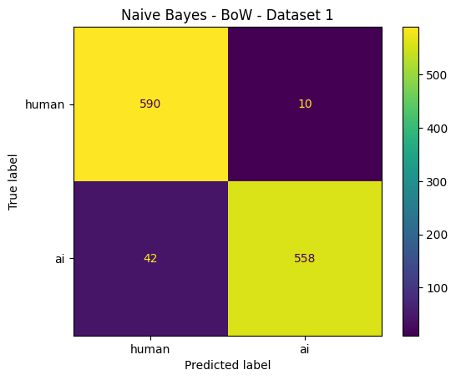
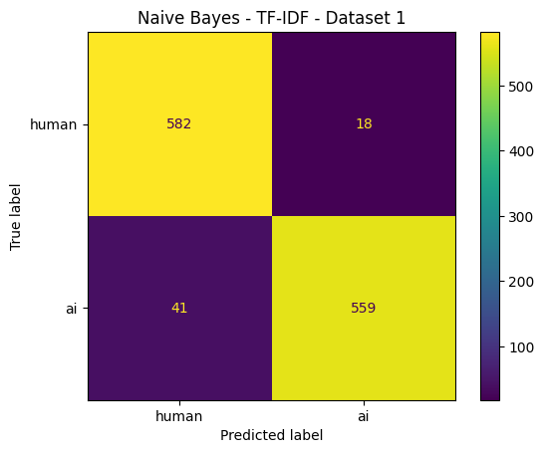
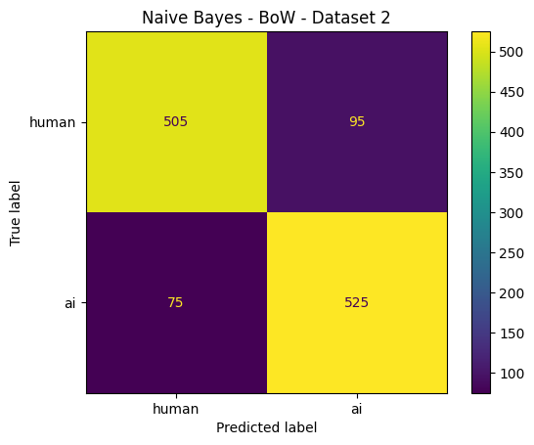
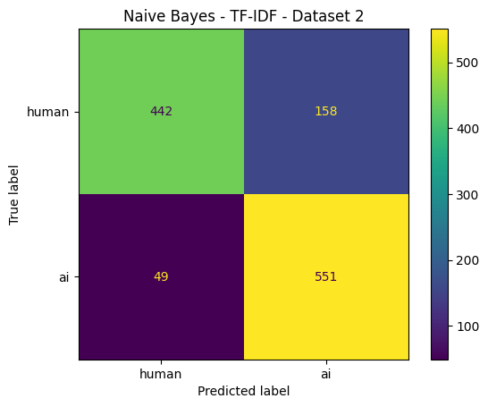
Confusion matrices for Naive Bayes models displayed above.

Code description:
The code defines a list of (representation, dataset) combinations, then loops through each pair to retrieve the stored true and predicted labels for the Naive Bayes model from the results dictionary. For each combination, it computes a confusion matrix, displays it with ConfusionMatrixDisplay using human/ai as labels, and titles the plot with the model name, representation, and dataset for clear identification.

- Logistic Regression
Description:
This task trains and evaluates a Logistic Regression classifier across all four combinations of feature representation (BoW, TF-IDF) and dataset (Dataset 1 - DAIGT V2, Dataset 2 - HC3), storing the results for later comparison against other models.
Code:
results[('Logistic Regression', 'BoW', 'Dataset 1')] = evaluate(LogisticRegression(max_iter=1000), X1_train_bow, y1_train, X1_test_bow, y1_test, 'Logistic Regression | BoW | Dataset 1 (DAIGT V2)')
results[('Logistic Regression', 'TF-IDF', 'Dataset 1')] = evaluate(LogisticRegression(max_iter=1000), X1_train_tfidf, y1_train, X1_test_tfidf, y1_test, 'Logistic Regression | TF-IDF | Dataset 1 (DAIGT V2)')
results[('Logistic Regression', 'BoW', 'Dataset 2')] = evaluate(LogisticRegression(max_iter=1000), X2_train_bow, y2_train, X2_test_bow, y2_test, 'Logistic Regression | BoW | Dataset 2 (HC3)')
results[('Logistic Regression', 'TF-IDF', 'Dataset 2')] = evaluate(LogisticRegression(max_iter=1000), X2_train_tfidf, y2_train, X2_test_tfidf, y2_test, 'Logistic Regression | TF-IDF | Dataset 2 (HC3)')

Sample output:
Logistic Regression | BoW | Dataset 1 (DAIGT V2)
precision recall f1-score support

0 0.98 0.99 0.98 600
1 0.99 0.97 0.98 600

accuracy 0.98 1200
macro avg 0.98 0.98 0.98 1200
weighted avg 0.98 0.98 0.98 1200

Accuracy: 0.9825
------------------------------------------------------------
Logistic Regression | TF-IDF | Dataset 1 (DAIGT V2)
precision recall f1-score support

0 0.97 0.99 0.98 600
1 0.99 0.96 0.98 600

accuracy 0.98 1200
macro avg 0.98 0.98 0.98 1200
weighted avg 0.98 0.98 0.98 1200

Accuracy: 0.9758333333333333
------------------------------------------------------------
Logistic Regression | BoW | Dataset 2 (HC3)
precision recall f1-score support

0 0.91 0.96 0.94 600
1 0.96 0.91 0.93 600

accuracy 0.93 1200
macro avg 0.93 0.93 0.93 1200
weighted avg 0.93 0.93 0.93 1200

Accuracy: 0.9333333333333333
------------------------------------------------------------
Logistic Regression | TF-IDF | Dataset 2 (HC3)
precision recall f1-score support

0 0.89 0.90 0.89 600
1 0.90 0.89 0.89 600

accuracy 0.89 1200
macro avg 0.89 0.89 0.89 1200
weighted avg 0.89 0.89 0.89 1200

Accuracy: 0.8925
------------------------------------------------------------
Logistic Regression model evaluation results stored in the results dictionary.

Code description:
The code instantiates a LogisticRegression model (with max_iter=1000 to ensure convergence) for each combination, calling the evaluate function with the corresponding training and test splits (BoW or TF-IDF vectorized features) for each dataset. Each call’s output is stored in the results dictionary under a key identifying the model, representation, and dataset, with a descriptive label passed to evaluate for identification during evaluation/reporting.

- Confusion matrices for Logistic Regression
Description:
This task generates confusion matrices for the Logistic Regression model across the same four representation/dataset combinations, enabling a direct comparison of its error patterns (false positives vs. false negatives) relative to the other classifiers.
Code:
combos = [('BoW', 'Dataset 1'), ('TF-IDF', 'Dataset 1'), ('BoW', 'Dataset 2'), ('TF-IDF', 'Dataset 2')]
for rep, ds in combos:
scores = results[('Logistic Regression', rep, ds)]
ConfusionMatrixDisplay(confusion_matrix(scores['y_true'], scores['y_pred']), display_labels=['human', 'ai']).plot()
plt.title('Logistic Regression' + ' - ' + rep + ' - ' + ds)
plt.show()
print('Confusion matrices for Logistic Regression models displayed above.')

Sample output:
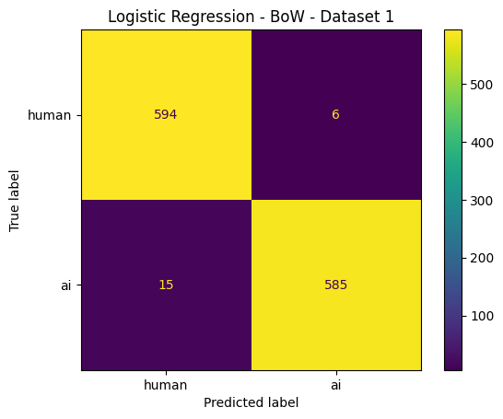
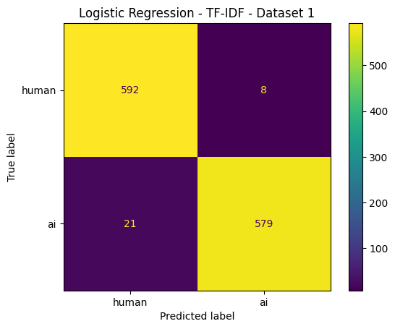
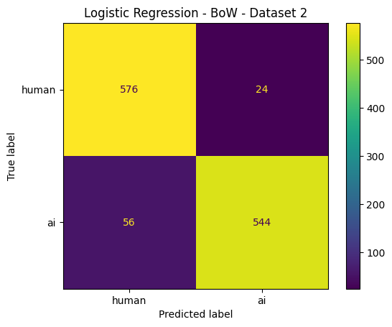
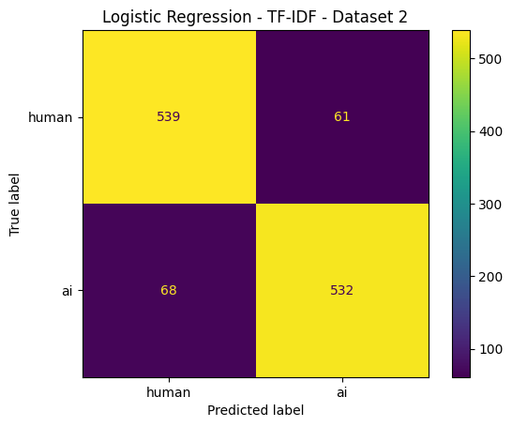
Confusion matrices for Logistic Regression models displayed above.

Code description:
Using the same combination list, the code fetches the Logistic Regression results for each (representation, dataset) pair, builds a confusion matrix from the true and predicted labels, and renders it via ConfusionMatrixDisplay. Each plot is labeled with the model, representation, and dataset name in the title before being shown.

- Support Vector Machine (LinearSVC)
Description:
This task trains and evaluates a Linear Support Vector Machine classifier across the same four representation/dataset combinations, completing the third model in the comparison alongside Naive Bayes and Logistic Regression.
Code:
results[('Support Vector Machine', 'BoW', 'Dataset 1')] = evaluate(LinearSVC(max_iter=5000), X1_train_bow, y1_train, X1_test_bow, y1_test, 'Support Vector Machine | BoW | Dataset 1 (DAIGT V2)')
results[('Support Vector Machine', 'TF-IDF', 'Dataset 1')] = evaluate(LinearSVC(max_iter=5000), X1_train_tfidf, y1_train, X1_test_tfidf, y1_test, 'Support Vector Machine | TF-IDF | Dataset 1 (DAIGT V2)')
results[('Support Vector Machine', 'BoW', 'Dataset 2')] = evaluate(LinearSVC(max_iter=5000), X2_train_bow, y2_train, X2_test_bow, y2_test, 'Support Vector Machine | BoW | Dataset 2 (HC3)')
results[('Support Vector Machine', 'TF-IDF', 'Dataset 2')] = evaluate(LinearSVC(max_iter=5000), X2_train_tfidf, y2_train, X2_test_tfidf, y2_test, 'Support Vector Machine | TF-IDF | Dataset 2 (HC3)')
print('Support Vector Machine model evaluation results stored in the results dictionary.')

Sample output:
Support Vector Machine | BoW | Dataset 1 (DAIGT V2)
precision recall f1-score support

0 0.97 0.98 0.98 600
1 0.98 0.97 0.98 600

accuracy 0.98 1200
macro avg 0.98 0.98 0.98 1200
weighted avg 0.98 0.98 0.98 1200

Accuracy: 0.9775
------------------------------------------------------------
Support Vector Machine | TF-IDF | Dataset 1 (DAIGT V2)
precision recall f1-score support

0 0.98 1.00 0.99 600
1 1.00 0.98 0.99 600

accuracy 0.99 1200
macro avg 0.99 0.99 0.99 1200
weighted avg 0.99 0.99 0.99 1200

Accuracy: 0.9875
------------------------------------------------------------
Support Vector Machine | BoW | Dataset 2 (HC3)
precision recall f1-score support

0 0.89 0.94 0.91 600
1 0.94 0.88 0.91 600

accuracy 0.91 1200
macro avg 0.91 0.91 0.91 1200
weighted avg 0.91 0.91 0.91 1200

Accuracy: 0.9116666666666666
------------------------------------------------------------
Support Vector Machine | TF-IDF | Dataset 2 (HC3)
precision recall f1-score support

0 0.91 0.90 0.91 600
1 0.90 0.91 0.91 600

accuracy 0.91 1200
macro avg 0.91 0.91 0.91 1200
weighted avg 0.91 0.91 0.91 1200

Accuracy: 0.9083333333333333
------------------------------------------------------------
Support Vector Machine model evaluation results stored in the results dictionary.
Code description:
The code instantiates a LinearSVC model for each combination and calls the evaluate function with the appropriate BoW or TF-IDF training/test features for Dataset 1 (DAIGT V2) and Dataset 2 (HC3). The results of each evaluation are stored in the results dictionary keyed by model, representation, and dataset, with a descriptive label identifying each specific run.
- Confusion matrices for Support Vector Machine
Description:
This task produces confusion matrices for the Support Vector Machine model across all four combinations, completing the set of visual diagnostics needed to compare classification behavior across all three models and both feature representations/datasets.
Code:
combos = [('BoW', 'Dataset 1'), ('TF-IDF', 'Dataset 1'), ('BoW', 'Dataset 2'), ('TF-IDF', 'Dataset 2')]
for rep, ds in combos:
scores = results[('Support Vector Machine', rep, ds)]
ConfusionMatrixDisplay(confusion_matrix(scores['y_true'], scores['y_pred']), display_labels=['human', 'ai']).plot()
plt.title('Support Vector Machine' + ' - ' + rep + ' - ' + ds)
plt.show()
print('Confusion matrices for Support Vector Machine models displayed above.')

Sample output:
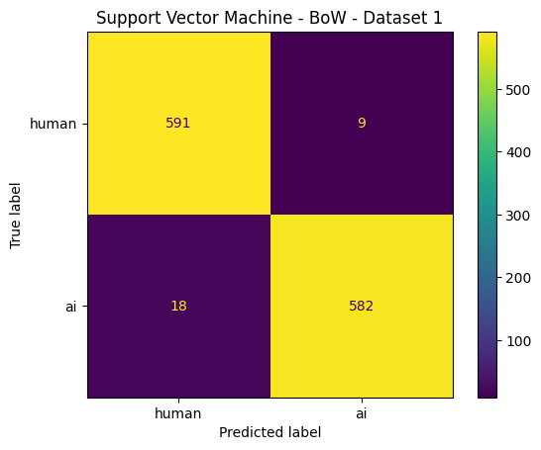
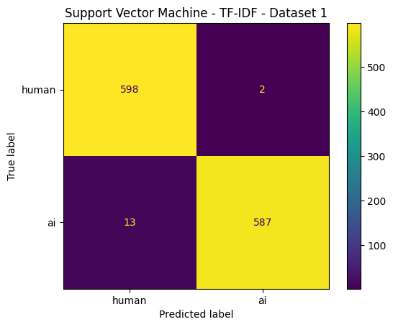
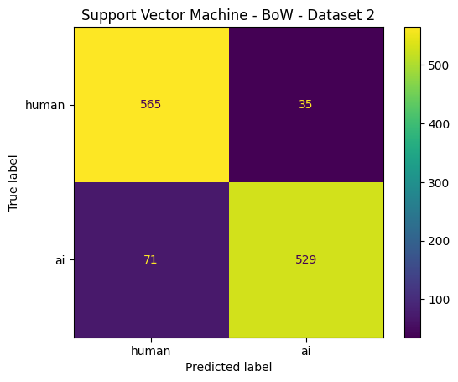
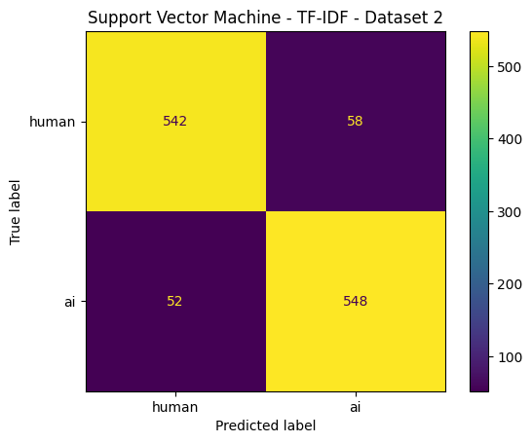
Confusion matrices for Support Vector Machine models displayed above.

Code description:
The code iterates over the same combinations, extracting the SVM model’s true and predicted labels from results for each (representation, dataset) pair. It computes and plots the confusion matrix with labelled classes (human, ai), titling each figure accordingly, and prints a summary message once all four plots have been displayed.

- Detailed metrics per algorithm (Accuracy, Precision, Recall, F1)
Description:
Accuracy on its own can disguise a lopsided model, so precision, recall and F1 are reported next to it. Grouped by algorithm, that works out to sixteen numbers each.
Code:
daigt_raw = pd.read_csv(path_daigt_download)
df1 = daigt_raw[['text', 'label']].dropna()
df1['label'] = df1['label'].astype(int)
print("=" * 60)
print("Dataset 1: DAIGT V2 Train Dataset")
print("Dataset Summary")
print("=" * 60)
print(f"Total Samples : {len(df1):,}")
print(f"Total Columns : {df1.shape[1]}")
print("\nClass Distribution")
print(df1['label']
.value_counts()
.sort_index()
.rename_axis("Label")
.reset_index(name="Number of Samples"))
print("\nFirst 5 Records")
print(df1.head())

Sample output:
Naive Bayes
Representation Dataset Accuracy Precision Recall F1
BoW Dataset 1 0.9567 0.9580 0.9567 0.9566
TF-IDF Dataset 1 0.9508 0.9515 0.9508 0.9508
BoW Dataset 2 0.8583 0.8587 0.8583 0.8583
TF-IDF Dataset 2 0.8275 0.8387 0.8275 0.8261
======================================================================
Logistic Regression
Representation Dataset Accuracy Precision Recall F1
BoW Dataset 1 0.9825 0.9826 0.9825 0.9825
TF-IDF Dataset 1 0.9758 0.9761 0.9758 0.9758
BoW Dataset 2 0.9333 0.9346 0.9333 0.9333
TF-IDF Dataset 2 0.8925 0.8926 0.8925 0.8925
======================================================================
Support Vector Machine
Representation Dataset Accuracy Precision Recall F1
BoW Dataset 1 0.9775 0.9776 0.9775 0.9775
TF-IDF Dataset 1 0.9875 0.9877 0.9875 0.9875
BoW Dataset 2 0.9117 0.9132 0.9117 0.9116
TF-IDF Dataset 2 0.9083 0.9084 0.9083 0.9083
======================================================================
Code description:
For each algorithm the loop reads its four stored metric sets and prints them as one table. Because the classes are balanced, the weighted precision, recall and F1 come out equal to their macro counterparts.
- Final Result Table [Accuracy]
Description:
This is the table the project brief asks for. Three algorithms and two representations down the rows, the two datasets across the columns.
Code:
rows = []
for algo in ['Naive Bayes', 'Logistic Regression', 'Support Vector Machine']:
for rep in ['BoW', 'TF-IDF']:
rows.append({
'Algorithm': algo,
'Representation': rep,
'Dataset 1': round(results[(algo, rep, 'Dataset 1')]['Accuracy'], 4),
'Dataset 2': round(results[(algo, rep, 'Dataset 2')]['Accuracy'], 4)
})

final_table = pd.DataFrame(rows)
print(final_table.to_string(index=False))

Sample output:
Algorithm Representation Dataset 1 Dataset 2
Naive Bayes BoW 0.9567 0.8583
Naive Bayes TF-IDF 0.9508 0.8275
Logistic Regression BoW 0.9825 0.9333
Logistic Regression TF-IDF 0.9758 0.8925
Support Vector Machine BoW 0.9775 0.9117
Support Vector Machine TF-IDF 0.9875 0.9083

Code description:
Two nested loops walk the three algorithms and the two representations, pull each accuracy back out of results, and hand the assembled rows to a DataFrame.

Result Table Discussion

Algorithm | Representation | Dataset 1 | Dataset 2
Naive Bayes | Bow | 0.9567 | 0.8583
 | TF-IDF | 0.9508 | 0.8275
Logistic Regression | Bow | 0.9825 | 0.9333
 | TF-IDF | 0.9758 | 0.8925
Support Vector Machine | Bow | 0.9775 | 0.9117
 | TF-IDF | 0.9875 | 0.9083

Description:
Logistic Regression and the Support Vector Machine beat Naive Bayes on both datasets, and the gap is not a rounding error. Naive Bayes paired with TF-IDF on HC3 is the weakest cell in the table at 0.8275, about sixteen points below the best score recorded on DAIGT. The sharper divide, though, is between the datasets rather than between the algorithms. Every model clears 0.95 on DAIGT while none of them reaches 0.94 on HC3. That fits what the two corpora are: the AI essays in DAIGT were generated from a short list of prompts and read very much alike, whereas HC3 answers are shorter, come from five different domains, and vary far more from one to the next, which leaves a weaker pattern to learn. The best result on DAIGT is the Support Vector Machine with TF-IDF at 0.9875, and the best on HC3 is Logistic Regression with Bag of Words at 0.9333. Between Bag of Words and TF-IDF the difference stays under a point for both linear models, so on this problem the choice of classifier matters more than the choice of representation. One limitation is worth stating plainly. These numbers come from a balanced 6,000-row sample of each dataset rather than the full corpora, and every test set was drawn from the same distribution as its training set. Nothing here shows how the models would behave on text from a generator they have never encountered.

